Pulaski County Community Health Assessment
Annual Update 2015

Pulaski County Health Center
& Home Health Agency

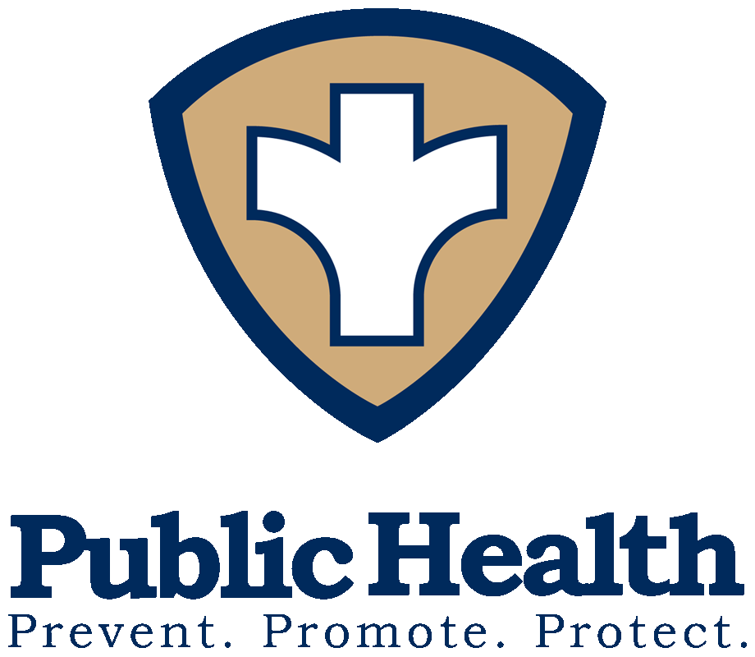
Demographic/Population Update
Pulaski County’s population is now estimated at 53,436 people; a slight increase since the 2010 Census level of 53,259. The population has remained stable the past few years following an exponential growth period from 2006 to 2012. The population by race is listed in Table 1.1 below and shows a slight decrease in the white alone percentage and a slight increase in all other races with the American Indian/Alaskan Native population remaining the same. The Hispanic ethnicity has also experienced a small increase. Additaional charactics of the population include an average total of veteran residents of 7,197 and foreign born residents are at 5.7% of the current population.

Population by Race and Ethnicity, Comparison 2012 to 2014
 | Percentage of Population 2012 | Percentage of Population 2014
White Alone | 79.2 | 77.8
Black Alone | 11.9 | 12.8
Am. Indian & Alaskan Native Alone | 1.0 | 1.0
Asian & Pacific Islander Alone | 2.8 | 3.7
Multiracial | 4.4 | 4.7
Hispanic | 9.7 | 10.7
Table 1.1- Source: Census Bureau, State & County Quick Facts: Pulaski County, Missouri

Income & Poverty

The county poverty rate in 2014 was at 15.9 percent which is a bit higher than the state rate of 14.8 percent. The per capita income for the county has decreased from $20,168 in 2011 to $20,019 in 2014. This is also below the state’s average per capita income of $28,555. Median household income in 2014 was at $49,604, lower than the state average of $53,482. Unemployment rates for 2014 were at 7.4% compared to the state unemployment rate of 6.1%. Of the current population under the age of 65, 12.1 percent is living with a disability and 14.4 have no health insurance.

Environmental Health Risk Factors

In early 2015, complaints were filed with multiply government agencies on the cleanliness of our local rivers and current e-coli levels. From a public health standpoint the Health Center worked on a plan to help protect local residents, patrons and tourists from potential e-coli infection. A partnership was formed with the Pulaski County Commission to launch a Water Monitoring Program to test a total of 8-10 local public access points on the Gasconade, Big Piney and Roubidoux. The program will be fully implemented in April 2016.

Public Safety

Drug Use
Illicit drug continues to rise and plague Pulaski County as it does many others. In 2013 there were 431 drug related arrests, up from 306 in 2011 and 325 in 2012. In 2013, there were 9 drug induced deaths in the county. For FY2014, there were 48 drug court participants, 123 probation/parole admissions and 60 prison admissions on drug charges. In the 2013-2014 school year, there were 37 students disciplined for drug related offenses, there were also 5 disciplined for alcohol and 1 for tobacco.

Death & Injury

There were 302 total deaths and 2396 injuries reported in Pulaski County in 2013. Table 4.1 shows a breakdown of deaths and injuries in 2013 compared to the two years prior.

Deaths & Injuries | 2013 | 2012 | 2011
Resident Deaths- Total | 302 | 300 | 297
Reported Injuries- Total | 2396 | 2537 | 2614
Suicides | 2 | 10 | 8
Self-Inflicted Injuries | 46 | 30 | 53
Unintentional Injuries | 2228 | 2361 | 2405
Homicides | 7 | 7 | 9
Assault Injuries | 101 | 123 | 114
Alcohol Induced Deaths | 3 | 3 | 4
Drug Induced Deaths | 9 | 10 | 14
Smoking Attributable Deaths | 62 | 56 | 57
Table 4.1- Source: 2015 Status Report on Missouri’s Substance Use and Mental Health; and MODHSS Injury MICA

Maternal & Child Health

The indicators of a child’s well being include many factors such as socio & economic and environmental. There are currently 16,352 children under the age of 19 in Pulaski County. Chart 5.1 shows the breakdown of the children & adolescent population ages by gender.

Chart 5.1- Source: MO DHSS, Population MICA

The 2015 County Health Rankings shows multiple areas that impact family health. Table 5.1 shows some of these areas and how well we are doing as compared with the State of Missouri.

Health Factor | Pulaski County | State of Missouri
Adult Smoking | 23% | 23%
Adult Obesity | 34% | 31%
Food Environment index | 6.6 | 7.0
Physical Inactivity | 27% | 26%
Access to exercise opportunities | 62% | 77%
Excessive drinking | 22% | 17%
Teen Births | 33 | 40
Uninsured | 16% | 16%
High School Graduation | 85% | 86%
Unemployment | 7.5% | 6.5%
Children in Poverty | 17% | 22%
Children in single-parent households | 26% | 34%
Severe housing problems | 12% | 14%
Table 5.1- Source: County Health Rankings, 2015

Women, Infants & Children (WIC)

WIC participation continues to decline despite efforts to recruit new eligible clients. Chart 6.1 below shows the trend of participation since FY2011. Note: The WIC fiscal year runs October 1 – September 30.

Table 6.1- Source: Pulaski County Health Center Board Report, October 2015

Communicable Disease

The prevention and spread of disease is a major public health concern. Prevention programs by education and/or screenings are provided throughout the community via presentations, display boards, news releases and public health updates.

Disease surveillance of local doctor’s offices, schools, nursing homes and child care facilities is collected and analyzed by the health department’s CD nurse and is forwarded to the Region Epidemiologist. The environmental specialist and/or community health nurse investigates any disease with an abnormal amount of increase. The leading communicable disease in Pulaski County is sexually transmitted diseases, which includes Chlamydia, Gonorrhea, and Syphilis.

Sexually Transmitted Disease: The health department does testing and treatment for sexually transmitted diseases during walk-in clinics on Mondays and by appointment Tuesday through Thursday. Treatment is provided to all positive cases and their partner(s). There were 124 office visits in 2014 for STD testing and treatment. Services for testing and treatment are on sliding scale fee and waived if patient cannot pay. There were 394 cases in 2014.
Chart 7.1 below shows the 2014 trend analysis of incidence or number of sexually transmitted diseases (Chlamydia, gonorrhea, and syphilis) in Pulaski County.

Chart 7.1- Source: PCHC Annual Report, 2015

Tuberculosis: The Pulaski County Health Department offers TB skin testing, TB medications (if indicated) and TB counseling / prevention education for residents of the community. When indicated (positive case), the health department offers case management to the clients – this includes monthly health assessments, medications as ordered, interaction with physician concerning the health status of the client, and frequent follow care with the patient and/or family. Visits related to the prevention and treatment of tuberculosis in 2014 was 173. This number can be misleading related to the decreased number of clients tested related to the New Day Care Requirements for employment.

Community Health Needs Assessment (CHNA)

A CHNA was completed during May and June 2015 in which there were 291 respondents. Among the items they were asked what they felt were the Top 5 Community Health Problems. The results showed that the top 5 selected were:
- Stress/Depression/Anxiety (130)
- Cancer (124)
- Diabetes (123)
- Heart Disease/Stroke (118)
- High Blood Pressure (113)

Among the top 10 was also motor-vehicle accidents, child abuse, access to health care, tobacco related illness, and clean environment.

Leading Causes of Death

According to the Missouri Department of Health & Senior Services Death MICA, the two leading causes of death in 2014 for both men and women in Pulaski County are Cancer and Heart Disease. The top 5 causes of Death for Pulaski County are:

- Cancer
- Heart Disease
- Chronic lower respiratory disease
- Stroke
- Unintentional injury

Summary

After assessing risk factors for health, the community’s top health concerns and the leading causes of death, there is confirmation that our strategic direction is correct. Our strategic goals include chronic disease prevention to reduce prevalence or heart disease and COPD, smoking-attributable diseases, and obesity-attributable diseases. The next Community Health Assessment is due to be completed in late 2016.

